|  |  |  |
| --- | --- | --- |
| SCHOOL OF INFORMATION AND TECHNOLOGY | | |
| NAME: BUSONGAN, DEMIRAYE-ANNE | DATE PERFORMED:25 SEP 2024 | /50 |
| Section: IDC1 | DATE SUBMITTED: 25 SEP 2024 |

# SYSADM1 – Monitoring Print Services in Windows Server 2019

# Requirement:

* A virtual machine running Linux and Windows OS

Part 1: Setting Up Print Services

1. Install and configure **print.srv** domain

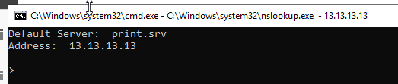

1. Connect one client to the recently created domain  
   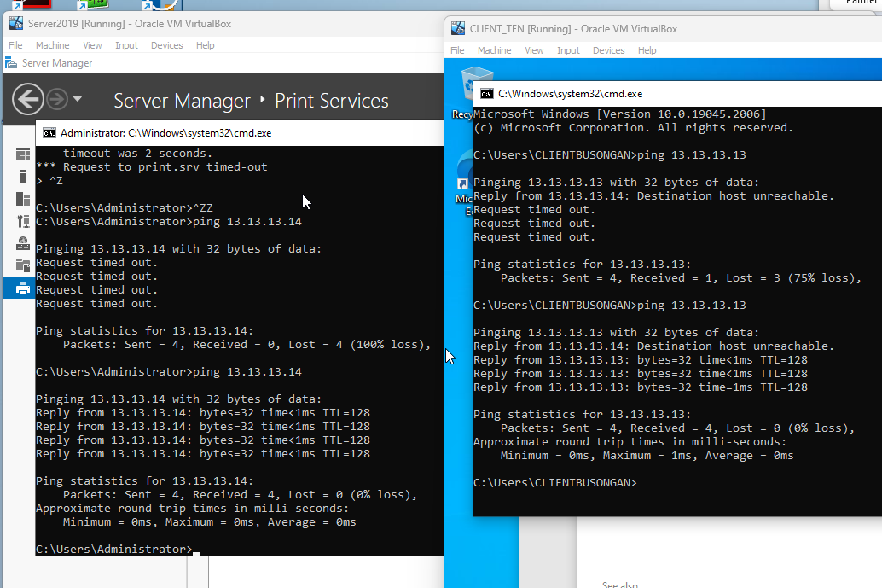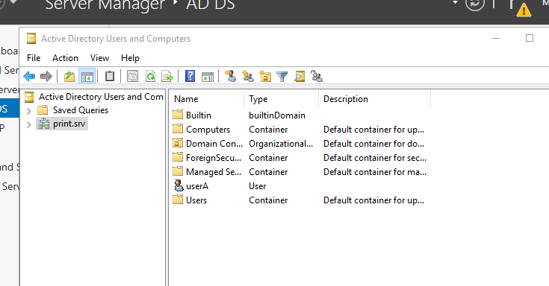

1. Install Print Services Role:  
   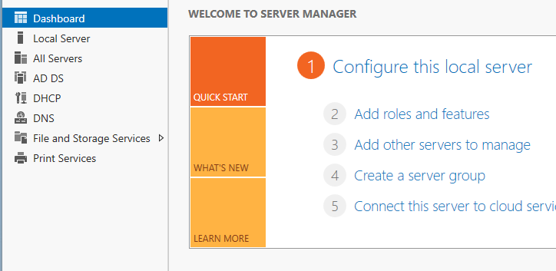
2. Search the internet for any printer installer and convert it to iso
3. Install and deploy it as network printer

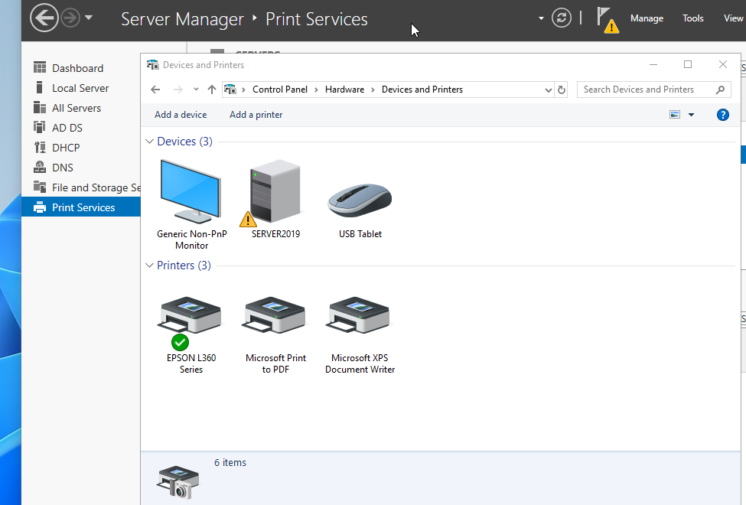

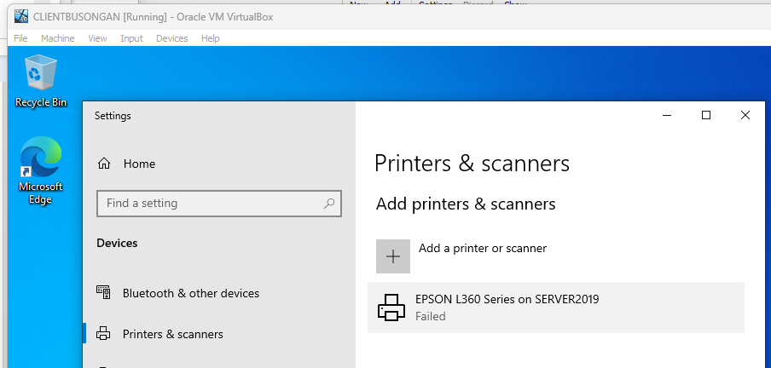

Part 2: Monitoring Print Services

Objective: Familiarize yourself with monitoring tools available in Windows Server 2019.

1. Event Viewer:
   * Open Event Viewer (run eventvwr.msc).
   * Navigate to Applications and Services Logs > Microsoft > Windows > PrintService.
   * Review logs for print jobs, errors, and warnings.

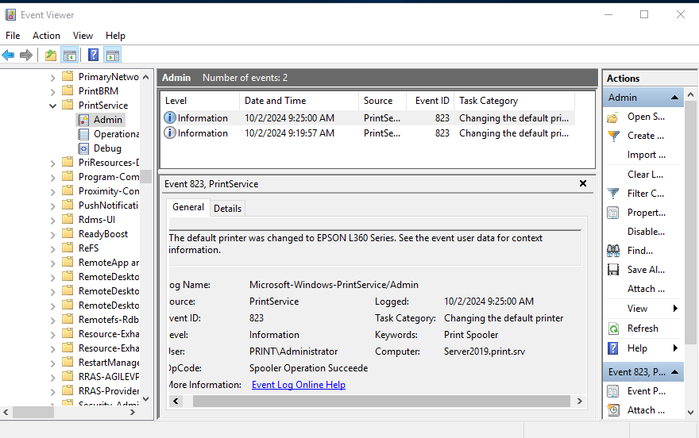

1. Performance Monitor:
   * Open Performance Monitor (run perfmon).
   * In the left pane, expand Data Collector Sets > System.
   * Right-click System Performance and select Start.
   * Monitor performance metrics related to print services.



1. Using Print Management Console:
   * Open Print Management from Server Manager.
   * View active print jobs and their status.
   * Use the Printers node to check the status of all printers.

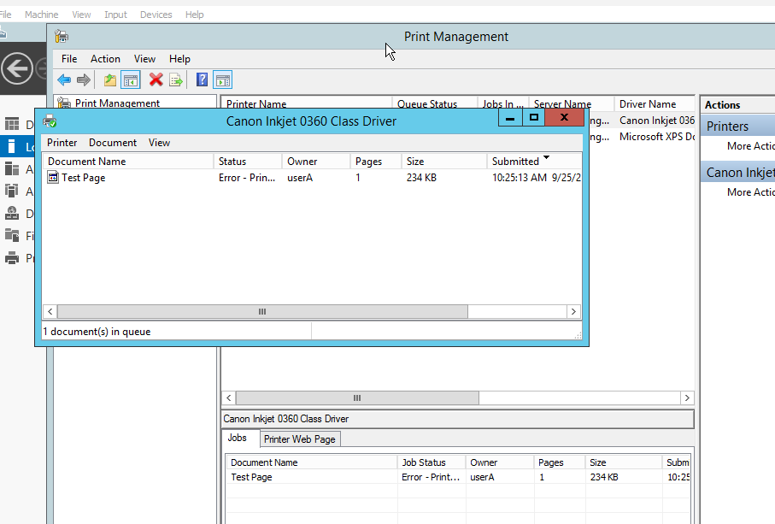

Part 3: Exploring Third-Party Monitoring Tools

Part 3: Exploring Third-Party Monitoring Tools

1. Research at least two third-party print monitoring tools
   * Consider factors such as features, pricing, and compatibility with Windows Server 2019.

## Factors to Consider for Cobra Print Viewer in Windows Server 2019 Environment

**Features:**

* **Compatibility with Windows Server 2019:** While the information provided states compatibility with Windows, it's essential to verify if Cobra Print Viewer explicitly supports Windows Server 2019.
* **Advanced Print Management:** The features offered by Cobra Print Viewer, such as viewing print job images, copying, reprinting, and redirecting jobs, are valuable for managing print queues in a server environment.
* **Integration with Server Environment:** Consider how Cobra Print Viewer integrates with other server management tools or Active Directory. This can simplify tasks like group policy management or centralized print queue control.

**Pricing:**

* **Cost-Effectiveness:** The free trial version allows for evaluation of the software's capabilities. However, the $45.00 price tag should be compared to other print management solutions available for Windows Server 2019.
* **ROI:** Evaluate if the features and benefits offered by Cobra Print Viewer justify the cost in terms of improved print management efficiency and potential cost savings.

**Compatibility with Windows Server 2019:**

* **OS Requirements:** Ensure that Cobra Print Viewer meets the minimum system requirements for Windows Server 2019, including .NET Framework version.
* **Driver Compatibility:** Verify if the software supports the print drivers used in your server environment. Any compatibility issues with specific printers or drivers could limit its functionality.

**Additional Considerations:**

* **Support and Updates:** Assess the developer's support services and update policy. Regular updates are crucial for addressing security vulnerabilities and improving compatibility.
* **Scalability:** If you manage multiple print servers or have a large number of print jobs, consider Cobra Print Viewer's scalability to handle the workload without performance degradation.
* **Alternative Solutions:** Research other print management solutions available for Windows Server 2019 to compare features, pricing, and compatibility.

1. **Print Inspector for Windows Server 2019: Features, Pricing, and Compatibility**
2. 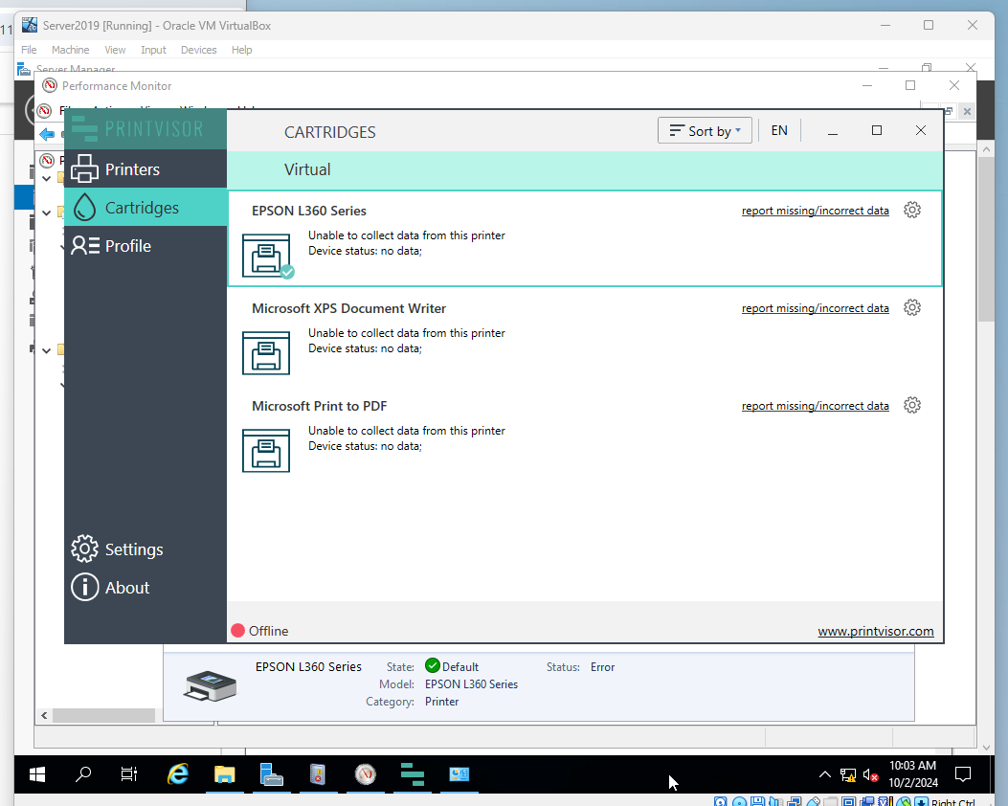

**Features:**

* **Monitoring and Auditing:** Print Inspector offers detailed tracking of print jobs, including document name, user, computer, date, and number of pages. This provides valuable insights into printing habits and resource utilization.
* **Print Queue Management:** You can pause, cancel, restart, or resume queued jobs. This allows for better control over print flow and helps prevent unnecessary printing.
* **Notifications and Actions:** Set up alerts for specific events like printer jams or large print jobs. You can even configure automatic actions, like sending emails or suspending large jobs, for more efficient management.
* **Reporting and Cost Analysis:** Generate reports ranging from simple job lists to comprehensive user and printer usage statistics. Export data to CSV or HTML for further analysis. This can help identify areas for cost reduction and optimize printer use.
* **Lightweight and Scalable:** The software's small footprint makes it suitable for various environments, including servers.

**Pricing:**

* **Free:** Print Inspector is a free software solution, making it a budget-friendly option for print management on Windows Server 2019.

**Compatibility with Windows Server 2019:**

* **Limited Information:** The provided information doesn't explicitly state compatibility with Windows Server 2019. It's crucial to verify compatibility directly with SoftPerfect, the developer.
* **Potential Challenges:** Since Print Inspector is a desktop application, running it directly on a server might not be ideal. It might require additional configuration or alternative server-based solutions.

**Additional Considerations:**

* **Server Management Tools:** Investigate native Windows Server 2019 print management tools for basic print queue control and monitoring. These tools might provide sufficient functionality depending on your needs.
* **Security:** Evaluate the security implications of installing a desktop application on a server. Consider user access controls and potential vulnerabilities before deploying Print Inspector.
* **Alternative Solutions:** Research dedicated print management software solutions designed specifically for Windows Server environments. These could offer additional features and better server integration.

1. Install and Configure:
   * Choose one of the tools to install in your environment.
   * Follow the installation instructions provided by the tool's documentation.
   * Configure it to monitor your print services.

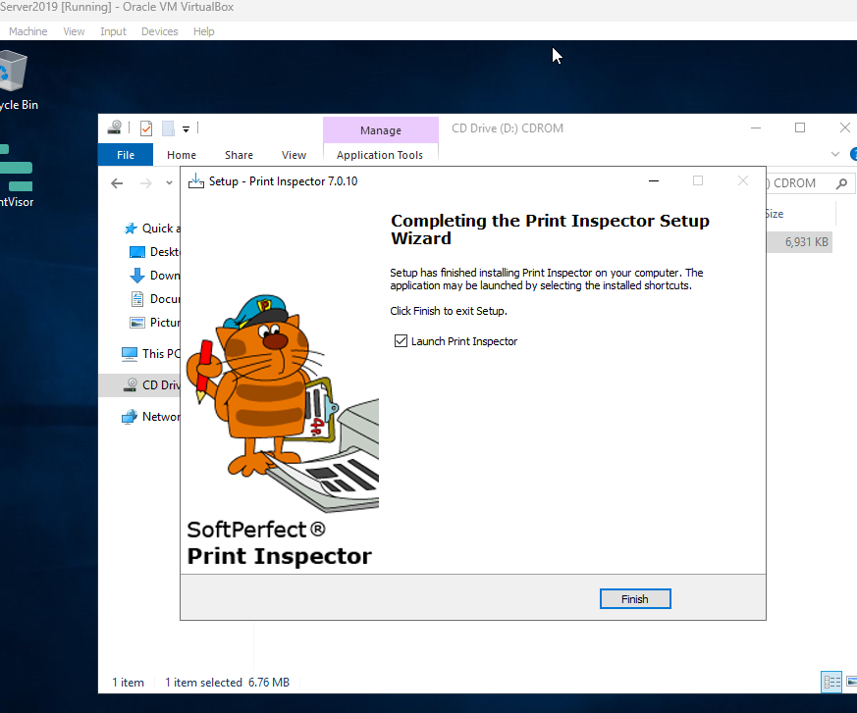

1. Test and Report Findings:
   * Generate a report or dashboard from the tool.
   * Analyze the collected data (e.g., print volume, errors, user activity).

Rubric

| **Criteria** | **1 (Unsatisfactory)** | **2 (Needs Improvement)** | **3 (Satisfactory)** | **4 (Good)** | **5 (Excellent)** | **Score** |
| --- | --- | --- | --- | --- | --- | --- |

|  |  |  |  |  |  |  |
| --- | --- | --- | --- | --- | --- | --- |
| **Part 1: Setting Up Print Services** |  |  |  |  |  |  |

|  |  |  |  |  |  |  |
| --- | --- | --- | --- | --- | --- | --- |
| **Domain Installation** | No domain created | Domain created with errors | Domain created correctly | Domain configured well | Domain configured and documented thoroughly |  |

|  |  |  |  |  |  |  |
| --- | --- | --- | --- | --- | --- | --- |
| **Client Connection** | Client not connected | Connection attempt failed | Client connected but with issues | Client connected correctly | Client connected and documented well |  |

|  |  |  |  |  |  |  |
| --- | --- | --- | --- | --- | --- | --- |
| **Print Services Role Installation** | Role not installed | Role installed with issues | Role installed correctly | Role installed and configured | Role installed, configured, and documented thoroughly |  |

|  |  |  |  |  |  |  |
| --- | --- | --- | --- | --- | --- | --- |
| **Printer Installer Conversion** | No installer found | Installer conversion attempted but failed | Installer converted but not used | Installer converted and used | Installer converted, used, and documented well |  |

|  |  |  |  |  |  |  |
| --- | --- | --- | --- | --- | --- | --- |
| **Network Printer Deployment** | Printer not deployed | Deployment failed | Printer deployed but not functional | Printer deployed correctly | Printer deployed, tested, and documented well |  |

|  |  |  |  |  |  |  |
| --- | --- | --- | --- | --- | --- | --- |
| **Part 2: Monitoring Print Services** |  |  |  |  |  |  |

|  |  |  |  |  |  |  |
| --- | --- | --- | --- | --- | --- | --- |
| **Event Viewer Usage** | Event Viewer not opened | Opened but no logs reviewed | Logs reviewed but superficial | Logs reviewed with some analysis | Logs reviewed with thorough analysis and documentation |  |

|  |  |  |  |  |  |  |
| --- | --- | --- | --- | --- | --- | --- |
| **Performance Monitor Usage** | Performance Monitor not opened | Opened but no metrics monitored | Metrics monitored but not analyzed | Metrics monitored with some analysis | Metrics monitored, analyzed, and documented thoroughly |  |

|  |  |  |  |  |  |  |
| --- | --- | --- | --- | --- | --- | --- |
| **Print Management Console Usage** | Console not opened | Opened but functionality not used | Active jobs viewed superficially | Active jobs viewed with some detail | Active jobs viewed and documented thoroughly |  |

|  |  |  |  |  |  |  |
| --- | --- | --- | --- | --- | --- | --- |
| **Part 3: Exploring Third-Party Tools** |  |  |  |  |  |  |

|  |  |  |  |  |  |  |
| --- | --- | --- | --- | --- | --- | --- |
| **Research on Tools** | No tools researched | Research incomplete | Research on one tool completed | Research on two tools with some analysis | Research on two tools, detailed analysis, and comparison |  |

|  |  |  |  |  |  |  |
| --- | --- | --- | --- | --- | --- | --- |
| **Installation and Configuration** | Tool not installed | Installation failed | Tool installed but not configured | Tool installed and configured with issues | Tool installed, configured, and documented thoroughly |  |

|  |  |  |  |  |  |  |
| --- | --- | --- | --- | --- | --- | --- |
| **Reporting Findings** | No report generated | Report lacks detail | Report generated but lacks analysis | Report generated with some analysis | Comprehensive report with thorough analysis and documentation |  |